PGR SPORTSFEST

125th FOUNDATION AND 81st LIBERATION ANNIVERSARIES OF THE PROVINCE OF ROMBLON

Governor’s Cup Women’s Open Invitational Volleyball Tournament

REGISTRATION FORM
Registration Fee: P 10,000.00
Champion : P 100,000.00
1st Runner-up : P 50,000.00
2nd Runner-up : P 30,000.00
3rd Runner-up : P 20,000.00
Team Name:
Team Manager: |  | Mobile Number:
Address:
OFFICIAL ROSTER
NO. | NAME | JERSEY NUMBER
1.
2.
3.
4.
5.
6.
7.
8.
9.
10.
11.
12’
Important Reminder for Registration Submission
- Please attach a screenshot of your GCASH or Bank Transfer payment together with your registration form when submitting to the committee.
- Each team must also attach one (1) valid Cedula
- GCASH No. : Nino Magracia – 09663808378
- LBP Account : Nino Magracia – 4366035970
Thank you.

Rules and Regulations
- General Provisions

- Governing Rules
- General Rules: The volleyball competition shall be held in accordance with the rules of International Volleyball Federation (FIVB) 2025-2028 Edition.
- Schedule
- Date: March 12, 2026
- The exact duration will depend on the number of registered teams.
- Adjustments may be made to ensure all matches (round robin, semi-finals, finals, and battle for 3rd) fit within the schedule
- Eligibility
- The Women’s Volleyball (Open Tournament) sets no limit on the number of players recruited from outside the province, provided they are officially listed in the lineup of a participating team.
- Teams may freely recruit athletes from within or outside Romblon, thereby allowing broad participation and encouraging diverse competition.
- Teams must submit their official roster (up to 12 players) one (1) week before the registration deadline on February 25, 2026.
- No roster changes or player additions will be entertained once the opening ceremony has started.
- General Uniform Rules
- Team Uniforms: All players on a team must wear identical uniforms, consisting of a jersey (shirt) numbered from 1-12 only., shorts/cycling/or any elastic leggings, socks, and athletic shoes numbered from 1-12 only.
- Libero Uniform: The libero’s uniform must have a different color than the rest of the team to make them easily distinguishable. The contrast must be clear and comply with regulations.
- 4.3.3.1 The number must be placed on the jersey at the centre of the front and of the back. The colour and brightness of the numbers must contrast with the colour and brightness of the jerseys.
- 4.3.3.2 The number must be a minimum of 15 cm in height on the chest, and a minimum of 20 cm in height on the back. The stripe forming the numbers shall be a minimum of 2 cm in width.
- 4.3.4 The team captain must have on his/her jersey a stripe of 8 x 2 cm underlining the number on the chest.
- Note: Teams incomplete uniform will be sanctioned 1 point in every game.
- Default and Forfeits in Volleyball
The term “default” refers to a team failing to show up or failing to field a valid team for a match. Defaulting a match often results in a forfeit, meaning that the team is automatically deemed the loser. Here’s how defaults and forfeits typically work:
Common Default/Forfeit Scenarios:
- Team Not Showing Up:
  - If a team does not show up for the match at the scheduled time—15 mins defaulting, this is considered a default. The team that is present automatically wins by forfeit.
- Not Having Enough Players:
  - Volleyball teams must have a minimum of six players to begin a match (in professional and competitive play).
  - If a team cannot field at least six players at the start of the match (due to injury, illness, etc.), this may be considered a default, and the team is forfeited from the match.
  - The specific number of players required can vary slightly depending on the level of competition (e.g., in recreational play, a team may be allowed to play with fewer players, but they would likely face penalties).
- No Show for a Scheduled Match:
  - If a team fails to arrive for a match, they may also face penalties beyond just losing the match, such as being disqualified from the tournament or league.
  - Late Arrival: If a team arrives late for a match but within a certain grace period (usually 15 minutes), they may still be allowed to play, but the match may start with a point deficit (e.g., the opponent is awarded points for the delay).
- Injuries or Dismissals:
  - If a team loses players due to injury or misconduct during the match (and cannot continue with at least six eligible players), the match may be forfeited by that team.
  - If a team is disqualified for violating tournament rules (such as playing with ineligible players), they might also face default.
- Serve
  - Serving Order: Teams serve in a predetermined rotation, and each player serves for a set period before rotating.
  - Service Fault: The serve must clear the net, land within the opposing team's court, and not touch any part of the net or any other obstruction. If the serve is faulty, the opposing team receives a point and gets the serve.
  - Service Delay: Teams must serve within a reasonable amount of time (usually 8-10 seconds) after the referee’s signal.
- Court Boundaries
  - Indoor Court: The court dimensions are typically 18 meters by 9 meters, with a centerline dividing the court into two equal sides.
  - Ball in Play: The ball must land within the boundaries of the court. If the ball lands outside the boundaries, the opposing team wins the rally.
  - Net: Players may not touch the net. If a player touches the net during a play, it’s a fault, and the opposing team wins the point.
- Play Rules
  - Contact: Each team can touch the ball up to three times before returning it over the net (these can include a block, but the block does not count as a touch).
  - Attack: A player may not attack the ball above the net if they are in the back row (unless they jump from behind the attack line).
  - Libero: In indoor volleyball, the libero is a designated defensive player who can replace any back-row player. They cannot serve, attack the ball above the net, or block.
- Fouls and Violations
  - Double Hit: A player cannot hit the ball twice consecutively, except for a block.
  - Four Hits: A team cannot hit the ball more than three times before returning it to the opposing team.
  - Foot Fault: A player serving the ball cannot step on or over the baseline while serving. • Over the Net: Players can’t interfere with the opponent’s play by reaching over the net (except for blocking). Players must also not cross the centerline with their feet or body.

- Sportsmanship & Conduct
  - Respect: Players, coaches, and spectators are expected to show respect for each other, officials, and the tournament environment. Unsporting conduct (e.g., arguing with referees, abusive language, etc.) may result in warnings or disqualification.
  - Fair Play: Teams should observe the principles of fair play, including not intentionally delaying play or distracting opponents.
- Tiebreakers
  - If a match is tied in terms of sets, the teams may play a final "decider" set (if not already predetermined in the match format), usually played to 15 points, the change of court will be in the score of 8 points.
- Equipment
  - Ball: A standard volleyball ball (size and weight to meet official specifications).
  - Uniform: Teams should wear matching uniforms, including numbered shirts. Nonmarking shoes are required for indoor tournaments to protect the court surface.
- Weather (for outdoor tournaments)
  - Rain or Extreme Weather: Tournaments will have a specific policy on weather delays or cancellations. If weather conditions are unsafe (e.g., lightning, heavy rain), play will be suspended or rescheduled and the score will be back to zero on the game or set started.

- Game Format and Progression
- Preliminary Round (8 teams above)
- If the number of registered teams exceeds 8, the tournament will be divided into two brackets.
- Each bracket will follow a single-elimination format until the Top 2 teams per bracket are determined.
- The Top 4 teams (2 from each bracket) will then advance to the Semifinals:
- Bracket A Winner (1) vs Bracket B Runner-up (2)
- Bracket B Winner (1) vs Bracket A Runner-up (2)
- Winners advance to the Championship Round.
- Losers will compete in the Battle for 3rd Place.
- Battle for 3rd Place
- The two losing teams from the semi-finals will play a single match.
- The winner will be declared 3rd Place, and the loser will be declared 4th Place.
- Championship Round
- The two winning teams from the semi-finals will play a single match. the winner will be declared the Champion.
- The losing team will be declared 2nd Place.
- Preliminary Round (7 teams below)
- Elimination Round:
- All teams will play in a single round robin format.
- Each team faces every other team once.
- Standings will be determined based on win–loss records (with tie-break rules applied if necessary).
- Semi-Finals:
- The Top 4 teams from the round robin advance.
- Match-ups will be:
  - Rank 1 vs Rank 4
  - Rank 2 vs Rank 3
- Finals & Battle for Third:
- Winners of the semi-finals advance to the Championship Match.
- Losers of the semi-finals will compete in the Battle for 3rd Place.
- Match Scoring System
- Set System: Matches are often played best of 3sets.
- Indoor: Each set goes up to 25 points (win by 2 points), except for the final set (if played) which is often played to 15 points.
- Winning the Match: The team that wins the majority of sets wins the match.
- Rally Scoring: Points are awarded on every rally, regardless of who serves.
- Side Out: The team that wins the rally gains the right to serve.
- Timeouts: Teams are typically allowed 1 or 2 timeouts per set (duration of timeouts usually 30-60 seconds).
- In case of equal matches won
- The following points will be awarded per match to each team:
Match won 2-0 | 3 points
Match won 2-1 | 2 points
Match lost 1-2 | 1 point
Match lost 0-2 | 0 point
Match forfeited 0 point | 0 point

- In case of equal points
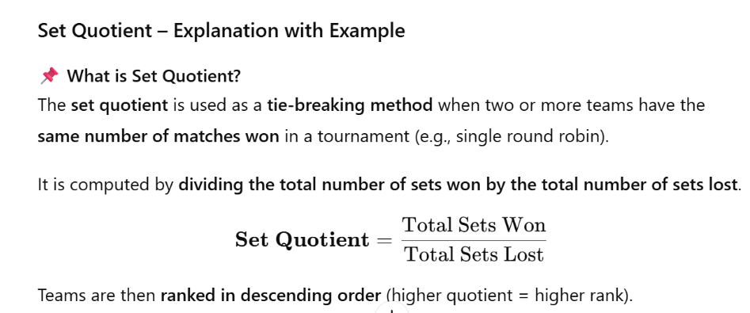
- Set quotient- in case of equality in the number of matches won by two or several teams, they will be classified in descending order by the quotient resulting from the division of the number of all sets won by the number of all sets lost.
- Points Quotient- if the tie persists as per set quotient, they will be classified in descending order by the quotient resulting from the division of all points scored by the total points lost during the match.
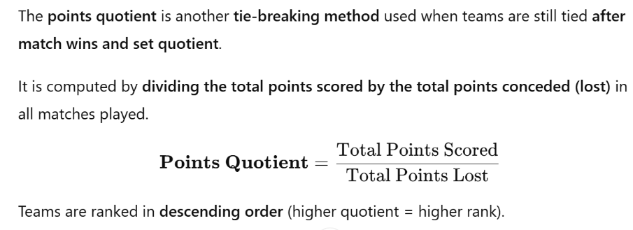
- Win over the other- if tie continues as per the points quotient between two teams, the priority will be given to the team which won the last match between them.

When tie in points quotient is between three teams, these teams ranked taking into consideration only the matches involving the teams in question.

- Ground Rules
- Sportsmanship: Fighting, abusive language, or disrespect toward officials will result in suspension.
- Protests: Must be filed in writing within 30 minutes after the game with a protest fee of P 1,500.00.
- Officials: Decisions of referees are final and binding.
- Safety: Players must wear proper shoes; jewelry is prohibited during play.
- Discipline: Teams or players who fail to comply with rules may be disqualified from the tournament.
- Uniforms: Teams must wear numbered jerseys in their town’s designated colors.
- No Registration Fee, No Game.
- Teams must be present 15 minutes before their scheduled game time.
- If a team fails to appear within the allocated 15 minutes before the start of the game, they will be declared default and will automatically lose the match.
- Strict enforcement of this rule ensures fairness and smooth flow of the tournament schedule.

VII. Miscellaneous
- The organizing committee reserves the right to amend rules when necessary.
- All participants are expected to uphold the spirit of the game and respect tournament officials.
- The registration fee collected will be used to cover honoraria & meals of officiating officials, and supplies for the duration of the tournament.

________________________________ IAN M. TUMANON, LPT, MEM
TEAM MANAGER/COACH HEAD OFFICIATING OFFICIAL
Signature Over-Printed Name Signature Over-Printed Name

________________________________
SPORTS COMMITTEE CHAIRPERSON
Signature Over-Printed Name

